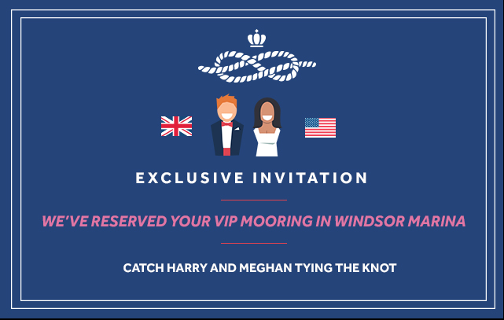
Le Boat cordially invites you to celebrate the Royal Wedding in style
Whether it’s street parties, grand picnics or other quintessential festivities, the British public certainly knows how to celebrate a royal wedding. On Saturday 19th May 2018 - when Prince Harry and Meghan Markle make their vows at St George’s Chapel, Windsor Castle - Britons will have plenty of reason to bask in the merry-making.
The level of demand for people visiting the UK and staying in Windsor and its environs has been phenomenal, with hotels (some as far away as Heathrow) charging up to £1,000 per night on the evenings surrounding the wedding.
In light of this, leading self-drive cruise operator Le Boat has reserved a limited number of exclusive mooring spaces for seven boats at MDL Marina in Windsor on Friday 18th May and Saturday 19th May. The marina is only three miles and a 13-minute taxi ride away from Windsor Castle, so guests staying there will be close to the action on the special day.
As well as being royally engulfed in the wedding fever, revellers will be delighted to find the boats decorated in bunting, and the fridges stocked with prosecco and nibbles to honour the special occasion. They can rustle up their own banquet-style feast on board the boats that have fully-equipped kitchens, or dine out in one of the many fine restaurants in the surrounding area.
On the day, guests can choose to watch the wedding where they like. Those who want to be part of the buzz around the castle can easily get to the heart of Windsor or find a cosy pub to watch the big event. With the wedding taking place from 2pm, guests will have plenty of time in the morning to cruise and explore. They can even journey down the river and watch from the comfort of their sundeck as the couple arrive, and then leave the castle as newlyweds.
The moorings at Windsor MDL Marina can be booked as part of an exclusive supplementary package added to bookings on the Thames over the Royal Wedding weekend. Le Boat is also offering a two-night return cruise from Chertsey available on seven boats (sleeping two to ten guests), including the moorings in MDL Marina, from Friday 18th May to Sunday 20th May. What better way to extend the jubilation than by making a mini holiday out of it?
The Royal Wedding Weekend supplementary package, including moorings at MDL marina, decorations and refreshments, costs £500 and must be added to another self-drive cruise on the Thames by calling Le Boat and quoting code RWWM.
The two-night cruise departing Friday 18th May from Chertsey is available from £1,174 on Caprice that sleeps up to six people. This cruise includes moorings at MDL Marina, decorations and refreshments and is also available on Classique Star, Horizon, Horizon 3 and Tango.
Numbers and mooring spaces are extremely limited with only seven boats or packages available and will be provided to customers on a first come, first serve basis.

Sample prices for self-drive cruises on the River Thames:
A seven-night self-catered stay on The Royal Cruise from Benson via Windsor on board Horizon that sleeps up to four people departing 16 May is priced from £2,206 per boat. No boating license or experience is needed.
A seven-night self-catered stay on The Majestic Cruise from Benson via Windsor on board Horizon 3 that sleeps up to eight people departing 18 May is priced from £2,715 per boat. No boating license or experience is needed.
Prices include boat rental and accommodation, towels and linen, locks fee, boat-handling demo and on-board cruising information. Travel to/from the base, fuel and Collision Damage Waiver are not included. Bike hire is available from £6 per day for adults; £4 per day for children.
For more information, contact Le Boat on 023 9280 9124 or visit www.leboat.co.uk

- Ends -
For media enquiries please contact Pippa Twigg pippa@heavenpublicity.co.uk or Lynsey Devon lynsey@heavenpublicity.co.uk or call +44 (0) 203 763 5170

About Le Boat: Le Boat is the largest operator of self-drive boating holidays on the waterways of Europe, operating its own fleet of 900 self-drive cruisers from a network of over 39 different departure bases across nine European countries. Le Boat brings together over 40 years of expertise and experience of Crown Blue Line and Connoisseur in Europe and Emerald Star in Ireland. From 2018 Le Boat will be offering the new Horizon fleet in Canada. Visit www.leboat.co.uk for more information.

